Intelligence management

1. Introduction

The Intelligence Store is a non-staffed store offering a selection of products and is available to members only. It relies on artificial intelligence, sensors, and cameras to track customers' locations and the products they have picked up from shelves. Customers must log into the Intelligence Store app and register their credit card to enter the store. The shopping cart contains sensors that track the barcode of each item placed in it. It contains a display screen to display the weight and value of the products that were placed in the product basket

The store's goal is to reduce the number of employees required significantly, rely heavily on artificial intelligence, and avoid long downtime in accounting for products purchased using traditional methods.

1.1 Purpose of the SRS Document

The software requirements specifications document is a high‐level view of the detailed

requirements needed for the widget that is to be designed. It includes the overall description of

the project, system features, use cases, and a broad range of requirements,[1]. It defines and documents the functional and non-functional requirements of the system.

1.2 Product Overview

Our online and traditional store offers a wide range of food products and combines a variety of packaged food products, including vegetables, canned goods, juices, and others.

Main goal: Our main goal is to provide a quick and easy personal shopping experience for the shopper by saving time waiting at checkout, and focusing on providing high-quality food products that meet different nutritional needs. Providing an application to purchase products through the store’s application for people who are unable to go to the store

--------------------------------------------------------------------------------------------------------------------------------------------------------

2. User Description

2.1 **User/Market Demographics**

Defining the target market for a smart store as the group of people who are likely to be interested in its products and services. In order for a smart store to successfully identify its target market, it needs to understand the needs and interests of potential customers.

The target market of a smart store can be defined as the group of people who are likely to be interested in its products and services. In order for a smart store to successfully identify its target market, it needs to understand the needs and interests of potential customers.

**Here are some demographic characteristics that can be used to determine the target market for the smart store:**

**Age:** People between the ages of 18 and 45 tend to be more likely to use digital technology.

**Location:** People who live in larger cities tend to be more likely to use digital technology,[2].

2.2 **User Profiles**

• Personal information: such as name, address, email, maps and gender.[3]

• Interests: such as hobbies, professional preferences, products and services that the user prefers.[3]

• History: such as browsing logs and login logs.[3]

• The operating system: This file includes information such as user name, password, and privacy settings.[3]

• Shopping Cart: The status of the items in the shopping cart.

• Sign-up and login history: To track user activity and login timing

• Data Privacy: User profiling can lead to the collection of large amounts of user data. This can raise privacy concerns.[5]

• Security: User profiles can be vulnerable to attack. This can lead to users' data being stolen.[5]

2.3 **User Environment**

• Access device: The store can be accessed via PCs, tablets and smartphones.

• Connect to the Internet: to browse the online store and make purchases online.

• Operating system: The project must be compatible with different operating systems such as Windows, macOS, iOS, and Android.

• Payment technologies: If there is a financial interaction, a variety of online payment methods and cash or cards must be supported in the physical store.

2.4 **Key User Needs**

• Efficient search system: To make it easier for users to find products quickly.

• Detailed product pages: Accurate and clear product information with high-quality images.

• Integrated Shopping Cart: Provide a seamless interface for adding and managing items in the shopping cart.

• Secure Payments: Providing safe and easy payment options.6. Shipping Tracking System: To provide accurate information about order and delivery status

• Customer Service: There are ways to communicate with the customer service team to solve any problem or respond to inquiries.

• An integrated experience between the online store and the traditional store.

3. Alternatives and Competition

There are several stores in Jordan that rely on an integrated system between the traditional store and the online store for selling food items, such as Carrefour, Safeway, and Cozmo. Your project contains a sensitive module used for the smart barcode found on each product. The customer just enters the shopping door, then picks up the products from the shelves and places them in the smart safe. For example, the Talabat application is an online store only. It does not combine the electronic and traditional aspects, and the rest of the mentioned companies do not present this idea as a “smart idea” and do not have workers.

4. Product Overview

4.**1 Product Perspective**

Some situations that may occur: In the event of a power outage, power generators must be provided.

4.2 **Summary of Capabilities**

• Track the location of products in the store

• Provides peace of mind with 24/7 customer support.

• Allow customers to scan items and see more information about them, such as reviews and pricing: This is done using mobile apps and barcode scanners.

• Interactive displays: Smart stores can use interactive displays to provide customers with information about products and to help them make purchasing decisions.

4.3 **Assumptions and Dependencies**

• Technology: Using a robust and secure online store platform.

• Digital Marketing: You need online marketing campaigns to reach a wide audience.

• Logistics: Selection of shipping services and electronic inventory management Traditional store Location:

• Requires a prominent and easy-to-reach place for customers

• Decoration and presentation: should be attractive and inspiring to visitors.

• Recruitment: Training sales staff to provide excellent customer service.

---------------------------------------------------------------------------------------------------------------------------------------------------------

5. Product Requirements

* Functional Requirement

**1.Log in and create an account:**

Ability for users to create a new account or log in using personal information or social media accounts.

**2.Products display**

View a complete list of products available for purchase, with ratings, photos and prices.

**3. Product Management:**

. Add, edit and delete products.

.Classification of products into sections.

.Upload pictures and prices of products.

**4. Search and filter**:

The ability to search for specific products and filter the results based on several criteria such as price and classification.

**5. User account management:**

The ability to modify personal account information and change the password.

**6. Manage your favorites list:**

The ability to create and manage a list of the user’s favorite products for easy access.

**7. Search by voice:**

Support voice search to improve user experience and increase convenience.

**8. Customer Support:**

Means of communication with the customer support team (live chat, email, phone)

**9. Add to Cart:**

The ability to add products to the user's shopping cart and update quantities

**10. Payment process:**

Support a secure payment interface for users to complete the purchase process and provide multiple payment options.

**11. Product evaluation:**

Allow users to provide ratings and opinions about products.

**12. Delivery management system:**

.Providing an interface for management to plan and follow up on delivery operations.

. Using GPS technologies to track drivers’ movement and improve delivery timing.

**13. Delivery timing:**

Determine time periods for delivering orders and clarifying them to customers.

**14. Designation of delivery areas:**

Determine the regions and geographical areas to which orders can be delivered.

**15. Providing multiple delivery options:**

Providing multiple delivery options such as express delivery and economic delivery.

**.16 Determine the delivery cost:**

Calculate delivery costs based on distance, weight or value.nable integration with shipping companies to calculate costs and track shipping

**17.Access control system:**

There must be a control system that prevents unauthorized access and allows authorized users to access.

**18.User interface:**

An easy-to-use interface that allows users to enter login data or use other means of login.

**19.Recording and documentation:**

Ability to log in and document activities within the store.

**.20 Monitoring**:

The ability to monitor entry and exit operations.

**.21 Integration with other systems:**

The ability to integrate with other systems within the store, such as the point of sale (POS) system.

Non- Functional Requirements

**1. Data integrity**:

Ensuring the security of user data and payment information .

**2. Compatible with multiple systems:**

Providing an application compatible with multiple operating systems such as iOS and Android.

**3. High performance:**

The application must be fast and reliable in responding.

**4. Excellent user experience:**

The application should be easy to use and comfortable for users.

**5. Round-the-clock availability:**

The application must be available around the clock without interruption.

**6. Load tolerance:**

The application must be able to handle a high load in cases of spikes in visitors or requests.

**7. Availability of backup copies**:

There must be a data backup strategy to deal with data loss situations.

**8. Compliance with Laws and Regulations**:

The application must comply with local and global laws and regulations.

**9. Technical support**:

An effective technical support service must be provided to assist users in case of problems.

**10. Attractive design:**

The design must be attractive and suitable for the target user group

**11. Translation:**

Support to translate the application into many languages ​​and adapt it to the requirements of the geographical location.

**12. Software testing and quality:**

Ensure application quality through comprehensive testing and debugging.

**13. Error management and continuous improvement:**

The ability to discover and fix errors and develop the application on an ongoing basis.

**14. Compliance with regulations and laws:**

The application complies with legal laws and regulations related to privacy and security.

**15. Provide documentation and support:**

Provide documentation and support for users to learn about using the application and solve problems.

**16. Ability to scan barcodes:**

The shopping cart must be able to scan the barcodes on products accurately and quickly.

(This can be achieved using a built-in scanner or camera)

**.17 Ability to store data:**

The shopping cart must be able to store product data, such as price and quantity.

( This can be achieved using a database or flash memory

**18. Ability to calculate totals**:

The shopping cart must be able to calculate a total based on stored product data.

(This can be achieved using a mathematical algorithm)

**. 19Data security:**

Ensuring the protection of user data and dealing with targeting hidden information via barcodes

**.20 Scanning quality:**

It is required that the sensitivity of the barcode allows for accurate and rapid scanning of barcodes and their accurate reading.

**.21 Compatibility with multiple types of barcodes:**

The ability to read different types of barcodes such as linear, QR, and Data Matrix barcodes.

**22 .Notifications and Warnings:**

Provide notifications when the barcode cannot be read effectively or when there is an error in the temporary data.

**23.Improved performance:**

Ensure the quality and barcode scanning capability and good user experience.

**24.Compatible with mobile technology:**

En 10. Ability to save and update: ensuring ease of maintaining the sensor and updating the software when needed.

**25.User Interface:**

Provide an easy-to-use user interface for smart users.

**26. Continuous testing and improvement**:

Conduct periodic tests and continuous improvements to improve the performance of the smart basket.

**27.Report security issues:**

Provide a way for employees to report any security issues that appear on the smart basket

**28.** **Protection against tampering:**

The ability to detect and prevent any attempts at tampering or forgery using the barcode.

**29. .Notifications and Alerts to Users:**

Provide notifications to users about barcode scans and related operations.

**30. Technical support:**

Providing technical support to store employees to address any technical problems that arise.

**31. Ease of use:**

Make the login process simple and easy to ensure easy access to the store.

**32. Compliance with laws and regulations**:

Ensure that the sensitive portal complies with legal regulations related to maintaining the confidentiality of user data

------------------------------------------------------------------------------------------------------------------------------------------------------6. Conclusions

* Increase production: Smart stores can produce many products, such as inventory management, customer tracking, and self-checkout. This can lead to harmful conditions changing.[4]
* Shopping experience: Stores can use personalized smart data to create a personalized shopping experience for each customer. This can include product recommendations; rewards offers and personalized services.[4]
* Intelligent control system: Stores can use technologies such as facial recognition and video analysis to prevent corruption.[4]
* Outdated initial investment and implementation costs: The cost of setting up and running a smart store can be cheap.[4]
* Possibility of ensuring the accuracy of privacy and security data: A smart store can collect large amounts of customer data, which may lead to increased privacy accuracy.[4]
* Limited human interaction with in-person customers: Human agents can effectively influence in-person customers.[4]

Problem Analysis

Traditional shopping has many problems that affect the user and the stakeholders, and one of the most important of these problems is

|  |  |  |  |  |
| --- | --- | --- | --- | --- |
| The Problem | Who is affected | What is the impact | The proposed solution | The key benefits |
| Wasting time and effort | the customer | Wasting time and effort searching for products and moving from one store to another if the desired product is not available | Developing e-commerce infrastructure | Comfortable shopping and no waiting |
| Difficulty comparing prices | the customer | Difficulty comparing prices leads the consumer to pay higher prices than the actual prices.[6] | Providing the ability to compare prices between different stores by browsing through the website | Get the best price |
| Store crowding | the customer | The consumer's inability to focus on the purchasing process. | There is no crowding or waiting to calculate the quantity or price of the product | Reducing staff and not having to stand to calculate the quantity and price of the product |
| Long wait at checkout | the customer | Spending time and wasting time standing around is useless | Provides baskets with sensors that calculate the total purchases and eliminate the need to stand in the line | Once you finish shopping, go to the gate that contains sensors and calculate the total purchases alone |
| Difficulty calculating the remaining quantities and products | stakeholders | It may lead to the product running out and not knowing the expiry date of the product | Entering products and expiration dates before placing them on the shelves and calculating the remaining quantities through the system | There is no need to throw away expired products |

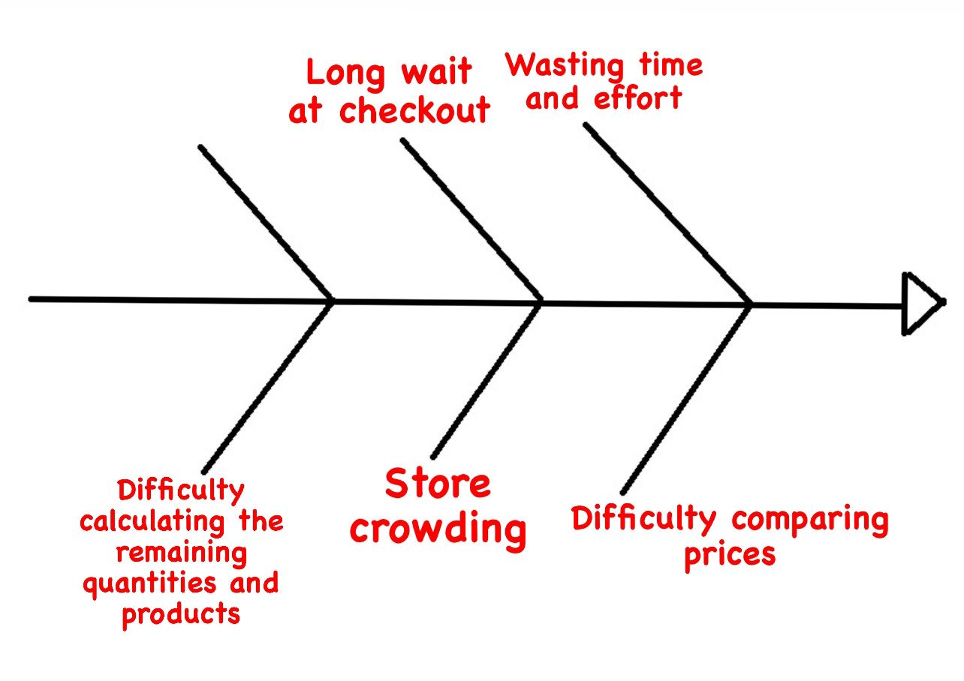

Figure 1-2 the fishbond diagram.

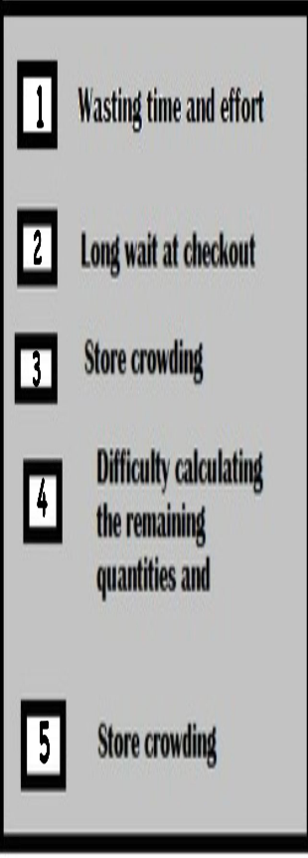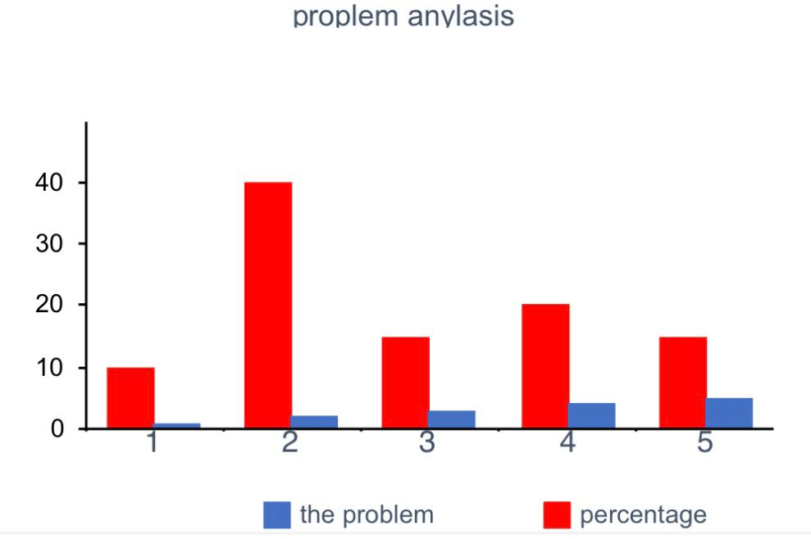

Figure 1-2 the bar chart .

Business Requirement

The emergence of smart stores has created an enjoyable and comfortable shopping experience for customers because the store contains sensors and pre-priced goods. With the smart store linked to its e-commerce application, the buyer will have a comfortable shopping experience and the ability to compare goods.

* Business Opportunity

**Advantages of Online Stores and AI Stores**

**-Wider reach:** Online stores can reach a global audience, whereas brick-and-mortar stores are limited to their physical location. [7,8]

**-Convenience**: Customers can shop online from the comfort of their own homes, at any time of day or night. [7,8]

**-Lower costs:** Online stores typically have lower operating costs than brick-and-mortar stores, as they do not need to pay for physical space or inventory. [7] Also by not paying employees' salaries due to a lack of.

**Benefits and the Problems to be Solved of Online and AI Stores for Businesses**

**-Increase sales and revenue**: Online stores can reach a much larger number of users than traditional stores. [7,8]

**-Enhancing customer satisfaction:** Online stores provide a comfortable shopping experience, evaluate existing products, and take opinions about their removal or pre Problems to be solved sense [7,8].

**-Lack of employees:** It will save us the huge sums paid to employees and provided to stakeholders

**-Reducing crowding at the cash register:** Having sensors capable of calculating the quantity and price of the product at both the shopping cart and the checkout door to calculate total purchases will reduce crowding of people.

* Business objective and success criteria

The business goal of artificial intelligence stores and electronic stores is to increase sales and revenues, and some of these goals are:

-Offer personalized discounts and promotions.

-Providing expenses related to employees, including salaries and others

- Providing 24/7 customer support through chatbots []

Success Will be Measured

**Sales growth**: Tracking sales growth over time is a key indicator of the effectiveness of an AI store's marketing and sales strategies.[9]

**Customer Satisfaction:** Customer satisfaction can be measured through surveys, feedback forms, and online reviews.

**Tracking existing quantities:** Artificial intelligence-based stores can track the remaining quantities, the quantities that are about to expire, etc.

* Customer and Market Need

The ability to serve customers 24 hours a day and 7 days a week through the artificial intelligence response service and the absence of the need for the presence of employees for the filling service. Once the customer enters the store, he can buy what he wants and put it in the basket, and the total of his purchases will be calculated automatically when he leaves the smart portal that contains Barcode sensors.

-----------------------------------------------------------------------------------------------------------------------------------

* Business Risk

Market competition

**-Risks:** Some of the most important risks for stores that rely on artificial intelligence are the presence of traditional stores that are popular and their location in an area that has the ability to compete with smart stores.

**-Strategic companies:** Smart stores can deal with many brands that have a request, or the store can deal with some electronic stores to provide them with cameras and electronics.

Timing

When entering the market, you must enter fully equipped and with all the tools to achieve the expected success to ensure the client’s trust in technology and confidentiality of information.

User acceptance

It is possible that all users feel comfortable with electronic stores and lack confidence in the systems. The system must have a high level of security and transparency. It is possible to mitigate the risks of user non-acceptance by creating an educational model before starting the purchase process to show users how to use the site or the smart store.

Implementation issues

Implementing AI-powered warehouses can be complex and resource-intensive. Technical challenges, data integrity issues, and regulatory resistance can hinder successful implementation. **Experienced Team:** Assemble a team with experience in AI, software development, and retail operations. To manage the projects well

Problem Analysis – Product Vision and Product Scope

Product Scope

The project includes providing sensors in the places where they must be available, cameras, electricity generators in the event of a power outage, smart gates to calculate the customer’s total, and ensuring communication between the store and the customer, such as tracking orders via GPS. The project does not include any malfunctions that occur on any of the devices.

Product Vision

**For** Shoppers of electronic stores and smart stores **Who** The store relies on electricity,AI, sensors, and cameras located in the place **The** intelligence management is An online store without employees linked to an application for the store. It also contains sensors at entry and exit and at the shopping cart. The customer pays via Visa, and the store is linked with an application for online purchasing. **That** The store contains sensors for the shopping cart's fast purchasing process and reduced purchasing time . **Unlike**  Traditional stores Which contains employees and the customer is guaranteed a purchase that includes waiting in line . **Our Projrect** It is a store in which there are no employees. It contains payment sensors and calculates the quantities in the shopping cart.

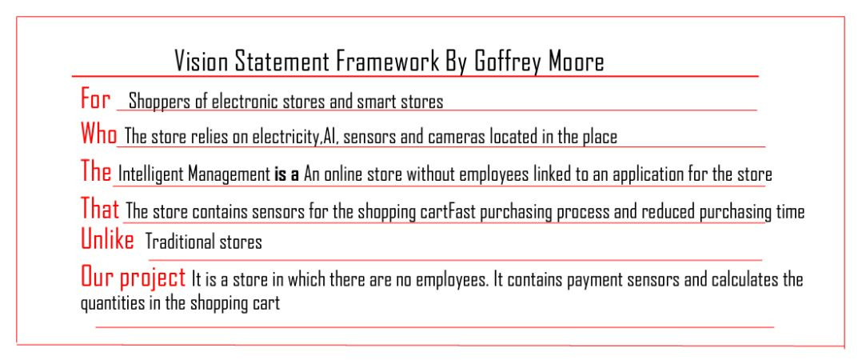

REFERENCES

[1] cs.purdue.edu‏ - Team – 2010 , <https://www.cs.purdue.edu/homes/cs307/ExampleDocs/SRS_teamE_Fall08.pdf> , 22/11/2023.

[2] Muhammad Abdullah and Muhammad Ahmed, Target market for the smart store, <https://www.sciencedirect.com/science/article/pii/S2307748023000038> , 22/11/2023.

[3] Muhammad Abdullah and Muhammad Ahmed, User profiles: concept, components, importance, security, and future, <https://www.sciencedirect.com/science/article/pii/S2345753922300033>, 22/11/2023.

[4] Yuan Wan and Qing Wang, Impact of Amazon Fresh on the Grocery Retail Industry, <https://rb.gy/oi0vml>,22/11/2023.

[5] Sebastian Auer and Andreas Felfernig and Erich Weippl, User profiles: Concepts, properties, and applications, ACM Computing Surveys (CSUR), <https://dl.acm.org/doi/pdf/10.1145/2501022.2501023>, 22/11/2023.

[6] Dr. Muhammad Abdullah Al-Khudairi, Problems of traditional shopping and their impact on the consumer, <https://www.iasj.net/iasj/article/97162>, 23/ 11/2023.

[7]. The Rise of E-commerce and the Business Opportunity for Online Stores, <https://www.linkedin.com/pulse/rise-e-commerce-importance-digital-marketing-online-sales>,23/11/2023.

[8] The Benefits of Online and AI Stores for Businesses, <https://link.springer.com/article/10.1007/s10796-021-10186-w>, 23/11/2023.

[9] The Rise of AI-Powered Retail: How AI is Transforming the Shopping Experience, <https://www.mckinsey.com/featured-insights/sustainable-inclusive-growth/chart-of-the-day/ai-tools-for-retailers>, 24/11/2023.